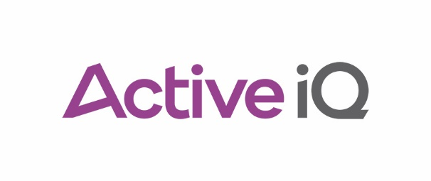 |  |  | Lesson plan
Unit title |  |  |  |  |  | Lesson number and title
Supporting behaviour change and healthy lifestyles |  |  |  |  |  | Lesson 4 – Healthy lifestyle
Planned face-to-face delivery time |  | Planned additional live learning support |  |  |  |  | Total guided learning hours (GLH)
2 hours, 30 minutes
Planned directed study time |  | Expected amount of learner-directed study |  |  |  |  | Total qualification time allocated to this lesson (GLH + directed and learner-directed study = TQT)
Teacher’s name |  | Date and time of lesson |  |  |  |  | Room/location
General resources |  |  |  | Specific unit resources
 |  |  |  | Active IQ |  |  |  |  | Centre
- Qualification guidance.  - Specific Assessment Guidance.  - Learner Achievement Portfolios (LAPs).  - Classroom, desks and chairs.  - Flipchart and pens.  - Whiteboard and pens. |  |  |  | - Content outline.  - Manual.  - PowerPoint.
Learning outcomes (the learners will):
LO2: Understand the importance of a healthy lifestyle
Assessment criteria (the learners can):
2.1 Explain the health risks of being overweight or obese
2.2 Describe the current prevalence of obesity in the UK
2.3 Explain the risks of an unhealthy lifestyle
2.4 Explain the benefits of a healthy lifestyle
2.5 Identify the risks and benefits of exercise for the prevention and management of common
health conditions
2.6 Identify sources of evidence-based, credible health and well-being information
Timing (in minutes) | Subject matter/activity overview |  |  |  | Learner activity |  |  | Resources |  | Assessment process and learning checks
5 minutes | State and display the learning outcomes and assessment criteria for the lesson.  Discuss these with learners. |  |  |  | Take notes. |  |  | PowerPoint. |  | Learner engagement, contribution and Q&A.
20 minutes | Lecture and interactive presentation – health risks of being overweight or obese. |  |  |  | Take notes. |  |  | PowerPoint.  Manual. |  | Learner engagement, contribution and Q&A.
40 minutes | Paired research activity – prevalence of obesity in the UK.  In pairs, research up-to-date statistics on obesity in the UK, in relation to:  - Demographics.  - Age.  - Gender.  - Socio-economic status.  - Previous years.  - Other countries globally.  - Treatment, for example, medication, bariatric surgery.  Note – there should be a focus on reputable sources of information, for example:  - Department of Health (DoH).  - NHS.  - Public Health England.  - British Medical Journal (BMJ).  - National Centre for Biotechnology Information (NCBI).  - British Nutrition Foundation.  - British Heart Foundation (BHF).  Each pair to present their findings to the class as part of a larger group discussion. |  |  |  | Research activity.  Paired discussion.  Group discussion. |  |  | PowerPoint.  Manual.  Internet access. |  | Learner engagement, contribution and Q&A.
30 minutes | Lecture and interactive presentation – benefits of an active, healthy lifestyle. |  |  |  | Listen.  Take notes.  Answer questions. |  |  | PowerPoint.  Manual. |  | Learner engagement, contribution and Q&A.
45 minutes | Paired activity – conditions associated with an unhealthy lifestyle.  Part 1 – discuss and identify health conditions that are associated with an unhealthy lifestyle.  Part 2 – discuss and identify the risks and benefits of exercise for the prevention and management of the health conditions identified in part 1.  Each pair to present their findings to the class as part of a larger group discussion. |  |  |  | Paired activity.  Group discussion.  Listen.  Make notes. |  |  | PowerPoint.  Manual. |  | Learner engagement, contribution and Q&A.
5 minutes | Lecture and interactive presentation – sources of evidence-based, credible health and well-being information. |  |  |  | Listen.  Take notes.  Answer questions. |  |  | PowerPoint.  Manual. |  | Learner engagement, contribution and Q&A.
5 minutes | Review and display the learning outcomes and assessment criteria for the lesson.  Discuss these with learners. |  |  |  | Take notes. |  |  | PowerPoint. |  | Learner engagement, contribution and Q&A.
Lesson evaluation:

- Which aspects of this lesson incorporated information and learning technology?
- Which aspects of this lesson incorporated functional skills?
- How were equality and diversity reflected in the lesson?
- Were all learners punctual?
- How did learners demonstrate their knowledge and understanding of the content?
- How did learners demonstrate their engagement during the lesson?
- Are there any other comments or notes relating to the lesson or learners?
- What personalised or customised learning strategies have you used?

